### **CHAPTER 1**

### **1. Introduction**

This section includes a brief overview of cryptocurrency, portfolio construction, problem statement, and the dissertation format.

*In your introduction, we expect you to introduce the problem. Tell us who else has worked on a related problem and their level of success and possibly the methods or tools they used. Tell us why you think this problem is important and is thus worth researching on. I expect a full page on the introduction.*

*Once you have completed your dissertation, i.e. have written your discussion (critical analysis) and the Conclusion, then you come back to Chapter 1 to complete the introduction by appending the results (e.g. using this tool and that tool, a success of 96% was achieved).*

#### **1.1 Background**

Following the 2008 global financial crisis, an unknown individual, group, or organization known as 'Satoshi Nakamoto' established an electronic peer-to-peer system based on the cryptocurrency bitcoin (Nakamoto, 2008). Bitcoin is a decentralized digital money that was established in 2008 and first used in 2009. It arose in response to financial firms that frequently privatized profits while socializing losses. Cryptocurrencies can solve various difficulties that have been passed down from previous financial systems, including a lack of confidence, transaction inefficiencies, and volatility. According to CoinMarketCap, 200,066 coins have entered into circulation with a market capitalization of more than $808 billion till December 2022. The technology driving the spread of cryptocurrencies is blockchain which is defined by Treiblmaier (2018) as "a digital, decentralized, and distributed ledger in which transactions are documented and appended in chronological order to establish permanent and tamper-proof records.”

Cryptocurrency makes use of blockchain technology to facilitate transactions and self-run decentralized platforms. Because blockchain is a distributed ledger system, when someone updates it, other nodes or computers are alerted. Figure 1.1.1 depicts the sequence of a bitcoin transaction from user A to B.

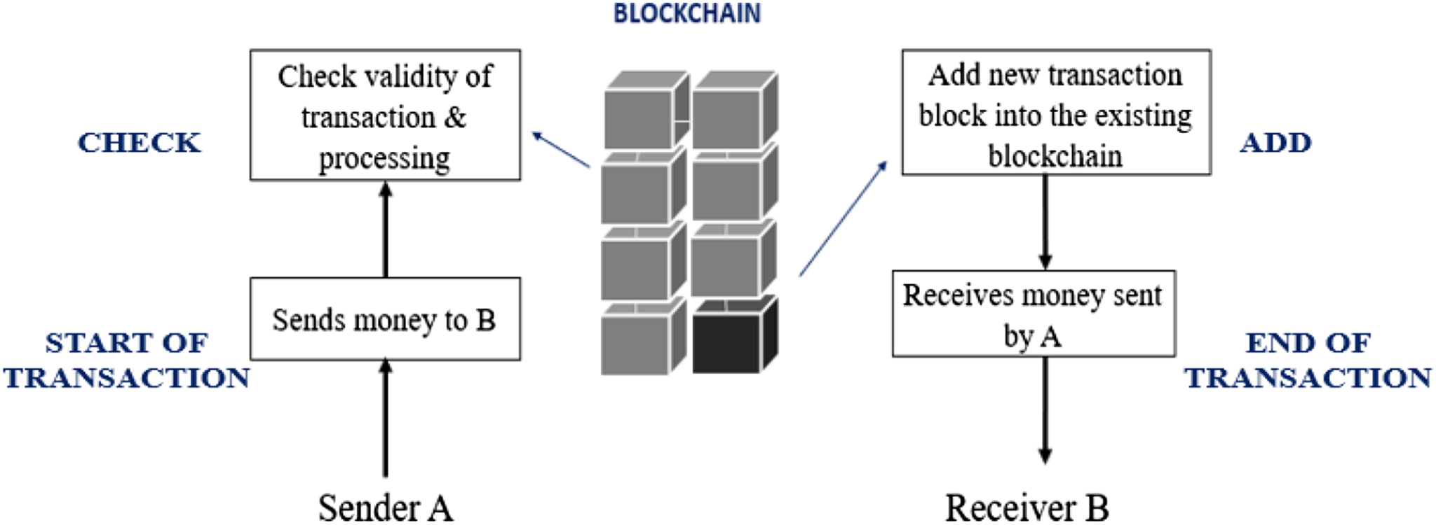

Figure-1.1.1**: Shows a bitcoin transaction from user A to user B**

If Sender A wishes to conduct a transaction with Recipient B, A will begin the transaction and record it on the public ledger, which is held by other cryptocurrency users. The transaction is placed on the blockchain when it has been verified. Miners verify transactions before they are recorded in the public ledger. Miners are compensated with cryptocurrency for verifying and maintaining the blockchain. The mining process necessitates the use of high-quality equipment and a powerful computer system **(please quantify)**.

Because of the following factors, blockchain technology makes cryptocurrencies more dependable.

1. Transaction encryption techniques prevent identity theft and make entities unhackable.
2. It makes use of the internet to make payments and money transactions quickly.
3. It is a type of virtual bank that can be accessed from anywhere, at any time, and users control the bank.
4. There is no intervention from a third party such as the government or a bank.

Cryptocurrencies have substantially faster settlement times than typical payment options. In the case of bitcoin, the average settlement time is 10 minutes, which is far faster than any non-cash financial transaction, which may take days or weeks. Although cryptocurrencies were established to facilitate the exchange of goods and services, Bitcoin, according to ARK and Coinbase, is the first of its kind in what is quickly becoming a unique asset class. Unlike bonds and stocks, cryptocurrencies may be prone to a "winner takes all" scenario because of the enormous network effects of users and developers. Cryptocurrencies that properly support the flywheel of user and developer interaction have the potential to expand to enormous market capitalizations. (Burniske & White, 2017).

#### **1.2 Problem Statement**

*What is the problem? You are talking a lot more about proffering a solution for a problem that you have not explicitly stated.*

*It is redundant to mention research article as we can see from your references section that it is a research article.*

Baur, Hong, and Lee (2018) presented **work** ~~a research article~~ based on a bitcoin analysis demonstrating that, while virtual currency's return attributes differ from traditional instruments, they provide significant diversity. Cryptocurrencies are volatile assets, and the following internal and external variables influence the price of cryptocurrencies. (2018) (Sovbetov) (Refer figure-1.2.1).

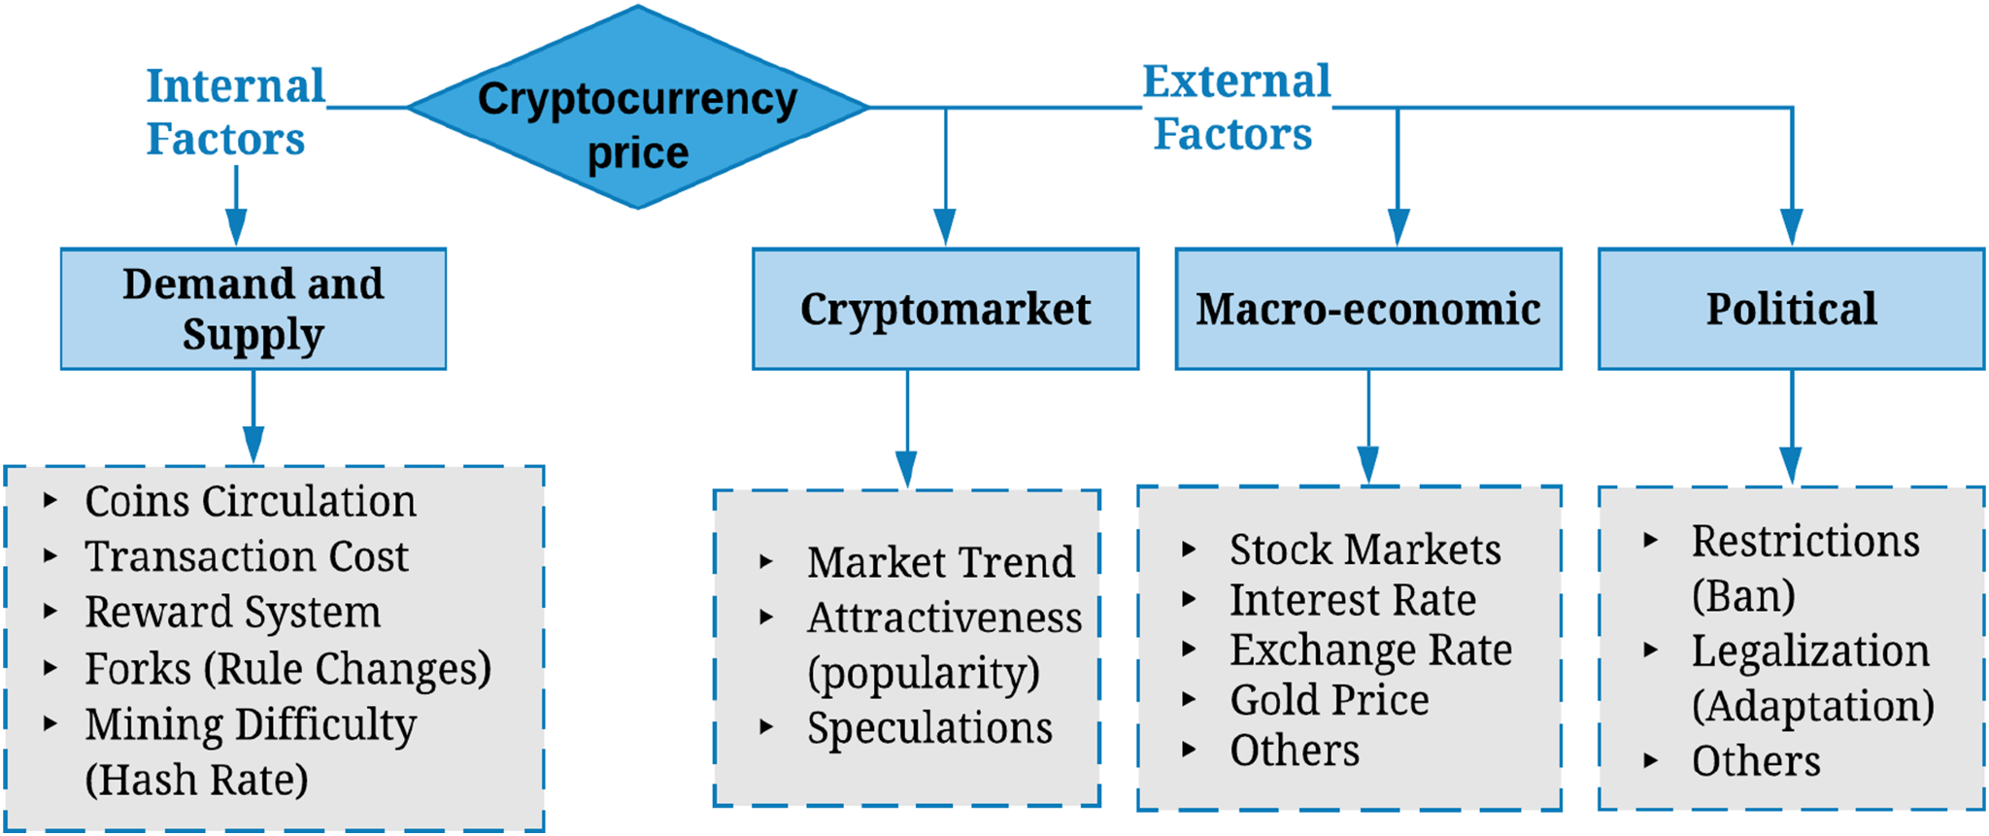

Figure-1.2.1: state what this is!

Move Figure 1.2.1 to Chapter 3.

#### To effectively invest in cryptocurrencies, portfolio construction is a crucial process that maximizes the return and minimizes the risk of the investment. The efficiency of the portfolio construction/optimization can be increased by changing the input forecast from historical data to a reliable one(DeMiguel et al., 2007). To address the problem, this study proposes a machine learning tool to derive the return of cryptocurrency for portfolio construction. Also, Construct the portfolios using different methods and analyze the performance of those portfolios. *You are no longer proposing, this is what you did. Your language must change from the one you used in your research proposal. You have already done the work. The language should be aligned to state that things were done and not ‘will be done’.*

The key deliverables **are capture by the set of** objectives **in Section 1.3.**  ~~of the project will be as follows:~~

#### **1.3 Objectives**

~~The key deliverables objectives of the project will be as follows:~~

1. A data collection of cryptocurrency stock data from Yahoo Finance or the Bloomberg terminal and exploratory analysis of data.
2. Forecast the price of time series data.
3. Portfolio construction utilizing several portfolio construction methods
4. Analyze the performance of built portfolios and compare them.

#### **1.4 Dissertation structure**

The structure of the report is divided into six sections: introduction, literature review, Methodology, Experiment, discussion, and conclusion, and flow is illustrated in figure-1.4.1.

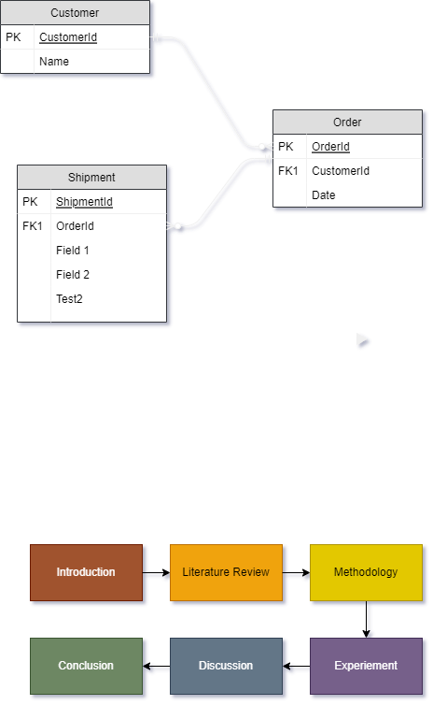

figure-1.4.1: **Shows ……**

The introduction provides context for this project by covering the background, issue description, and objectives, as well as details about cryptocurrencies and portfolio construction. Following that, the Literature review part describes the current literature and research in the field of the selected project themes and identifies gaps. After that, in the methodology section, methodologies and algorithms will be discussed/compared in order to finalize the approaches used for the experiment. The experiment will be carried out using the procedures described in the previous part, and the results will be reviewed in the experience section. The results of the experiment will be discussed and concluded in the next two chapters, as will the research on the proposed subject. ***The introduction starts with introducing the problem. The problem that is the question that the dissertation sets out to answer. The other things follow after that which includes background information and objectives.***

**Reference:**

[1] Nakamoto, S., 2008. Bitcoin: A peer-to-peer electronic cash system. *Decentralized Business Review*, p.21260.

[2] Rejeb, A., Rejeb, K. and Keogh, J.G., 2021. Cryptocurrencies in Modern Finance: A Literature Review. *Etikonomi*, *20*(1), pp.93-118.

[3] Treible Maier, H., 2018. The impact of the blockchain on the supply chain: a theory-based research framework and a call for action. Supply chain management: an international journal.

[4] Malik, S. and Rana, A., 2020. A brief survey of cryptocurrency systems. *IITM JOURNAL OF MANAGEMENT AND IT*, *11*(1), pp.76-82.

[5] Burniske, C. and White, A., 2017. Bitcoin: Ringing the bell for a new asset class. *Ark Invest (January 2017)* [*https://research.ark-invest.com/hubfs/1_Download_Files_ARK-Invest/White_Papers/Bitcoin-Ringing-The-Bell-For-A-New-Asset-Class.pdf*](https://research.ark-invest.com/hubfs/1_Download_Files_ARK-Invest/White_Papers/Bitcoin-Ringing-The-Bell-For-A-New-Asset-Class.pdf)

[6] Sovbetov, Y. (2018). Factors Influencing Cryptocurrency Prices: Evidence from Bitcoin, Ethereum, Dash, Litcoin, and Monero. *Journal of Economics and Financial Analysis*, [online] 2(2), pp.1–27. Available at: https://econpapers.repec.org/article/trp01jefa/jefa0016.htm [Accessed 20 Dec. 2022].

[7]‌ Baur, D.G., Hong, K. and Lee, A.D. (2018). Bitcoin: Medium of exchange or speculative assets? Journal of International Financial Markets, Institutions, and Money, 54, pp.177–189. doi:10.1016/j.intfin.2017.12.004.

‌[8] DeMiguel, V., Garlappi, L. and Uppal, R. (2007). Optimal Versus Naive Diversification: How Inefficient is the 1/NPortfolio Strategy? Review of Financial Studies, [online] 22(5), pp.1915–1953. doi:10.1093/rfs/hhm075.

‌